Progressive Farmer: Smt. S. Dhanalakshmi, Birdline, S. Andaman

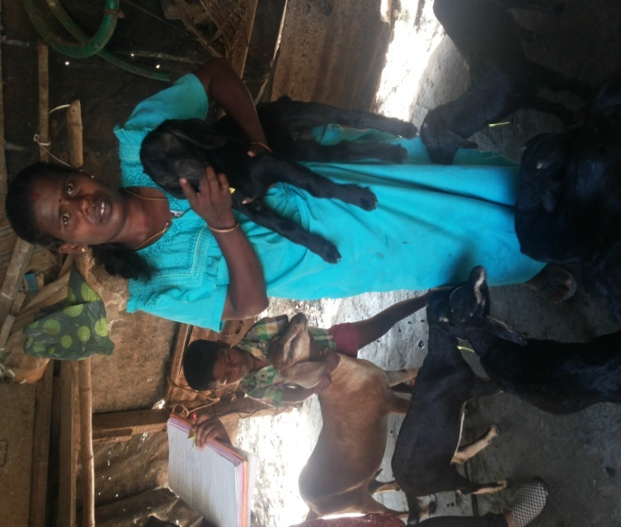
Smti. S. Dhanalakshmi, aged 36 years, w/o Shri. P. Singaram, a resident of Birdline, South Andaman started goat farming with 6 goats about five years back. Presently, she is having a total of 23 goats which are being maintained in wooden shelter with pucca floor. Her husband, Shri. P. Singaram, a private labour attended a training programme on scientific rearing of goats conducted at Calicut village. She is very much interested about the scientific way of goat rearing and contacted the ICAR-CIARI for technical advice for improving the productivity. ICAR-CIARI Scientists visited Smti. Dhanalakshmi’s house and suggested the technical guidance regarding, feeding, housing, timely deworming, health management and selection of superior germplasm. With the constant support and guidance of ICAR-CIARI, she has increased her stock to 23 goats and is very much happy about the progress. She has started feeding mineral supplementation and doing regular deworming which has caused great impact in term of body weight gain and increase in reproductive efficiency. She informed that they are earning approximately Rs. 60000 per annum by selling of goats. With the earning from goat farming they have been supporting their family and are totally dependent on goat farming for livelihood.

